**Implementation of Tree Topology**

**Step 1:** First, open the Cisco packet tracer desktop and select the devices given below:

| **S.NO** | **Device** | **Model-Name** |
| --- | --- | --- |
| **1.** | PC | PC |
| **2.** | switch | PT-switch |

| **S.NO** | **Device** | **IPv4 Address** | **Subnet Mask** |
| --- | --- | --- | --- |
| **1.** | pc0 | 192.168.0.1 | 255.255.255.0 |
| **2.** | pc1 | 192.168.0.2 | 255.255.255.0 |
| **3.** | pc2 | 192.168.0.3 | 255.255.255.0 |
| **4.** | pc3 | 192.168.0.4 | 255.255.255.0 |
| **5.** | pc4 | 192.168.0.5 | 255.255.255.0 |
| **6.** | pc5 | 192.168.0.6 | 255.255.255.0 |

Use an Automatic connecting cable to connect the devices with others.

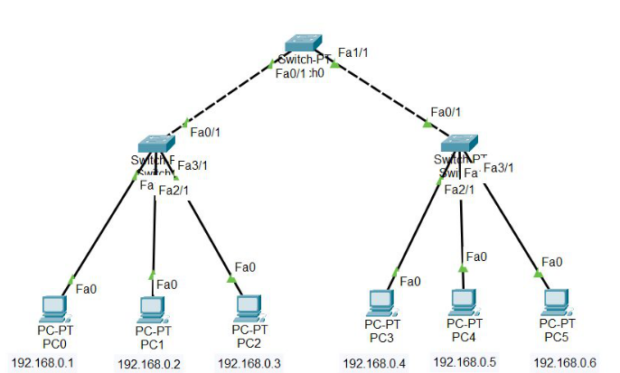

**Step 2:** Configure the PCs (hosts) with IPv4 address and Subnet Mask according to the IP addressing table given above.

* To assign an IP address in PC0, click on PC0.
* Then, go to desktop and then IP configuration and there you will IPv4 configuration.
* Fill IPv4 address and subnet mask.

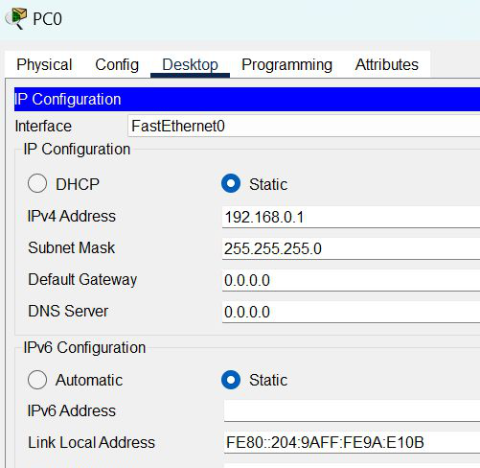

* Assigning an IP address using the ipconfig command, or we can also assign an IP address with the help of a command.
* Go to the command terminal of the PC.
* Then, type ipconfig <IPv4 address><subnet mask>

ipconfig 192.168.0.1 255.255.255.0

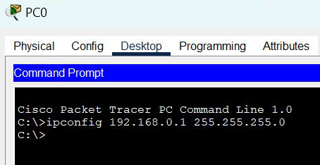

* Repeat the same procedure with other PCs to configure them thoroughly.

Step 3: Verify the connection by pinging the IP address of any host in PC0.

* Use the ping command to verify the connection.
* We will check if we are getting any replies or not.
* If we can see, we are getting replies from a targeted node on both PCs.
* Hence the connection is verified.

